Date: 24/11/2025

Lab Practical #01:
Research and find out what are the current UI/UX design trends. Study of various templates. E.g. Metronic, Unify, AdminLTE, etc.

Practical Assignment #01:
Choose one of the example templates (Metronic/Unify/AdminLTE, etc.) and analyze it. Fill out a worksheet with these headings:
- First Impression: What is this template's primary goal?
- Target User: Who do you think this was designed for?
- Key UI Pattern: Identify one UI pattern (e.g., the sidebar navigation) and describe how it works.
- A/B Opinion: What is one thing you think it does well, and one thing you would improve?

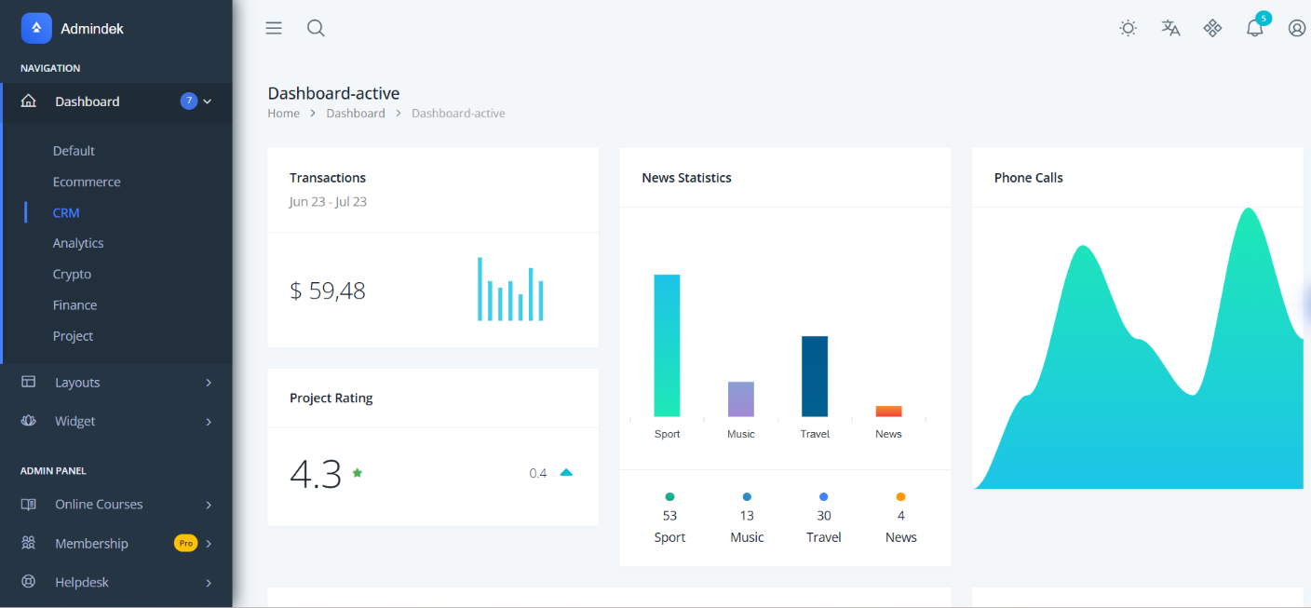
Description:

First Impression: Primary Goal
The template’s primary goal is to provide a clean and modern analytics dashboard where users can quickly view key performance statistics such as transactions, news statistics, and phone call trends. The design focuses on quick data visualization, status monitoring, and easy navigation through different modules like CRM, Analytics, Finance, and Projects.

Target User
This dashboard is designed for business managers, project managers, CRM or sales teams, administrators, and data analysts.

Key UI Pattern: Sidebar Navigation (Primary Pattern)
Pattern: The template prominently uses a left fixed sidebar navigation, a very standard UI pattern in admin dashboards. How it works:

Date: 24/11/2025
  - Always visible: It stays fixed on the left side, allowing users to switch sections instantly.
  - Icon + Text structure: Icons help quick identification, while text provides clarity.
  - Expandable menus: Some sections (Layouts, Widget, Online Courses, Membership, Helpdesk) contain dropdown arrows for nested items.
  - Badge indicators: Dashboard has a small circular badge showing 7, indicating pending items or notifications.
  - Color contrast: Dark background sidebar helps differentiate from the light main workspace.

A/B Opinion
  - One thing it does well: Clear Visual Hierarchy & Modern UI: The dashboard uses clean card layouts, bright colors, and well-spaced charts that make key metrics easy to understand at a glance. Important numbers (like ratings and revenue) stand out clearly due to strong typography and color contrast.
  - One thing I would improve: Layout Consistency: Some cards have dense content while others look too light, which breaks the visual balance. Aligning the spacing and structuring the cards more uniformly would make the dashboard feel more organized and consistent.

